
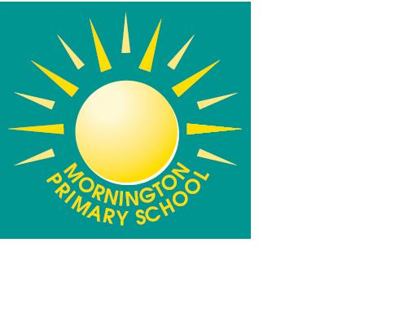

Pupil In-Year Application Form: Mornington Primary School
This form should be completed by the child’s parent/carer with parental responsibility for an in-year admission application or consideration of a change of school. All information given concerning individual children and families remains confidential.

Child’s Full Name:

Date of Birth:  Childs Current Year Group: | Boy Girl  (Please circle)

Childs Current Address  Post code: | Do you think you may be entitled to free school meals (please circle)  Yes / No  Families of service personnel  Please indicate if either parent has a confirmed posting or is a crown servant returning from overseas? (please circle)  Yes / No  Further details:

Childs Current School ______________________________

School Address

Post code:

Ethnicity | Religion
White-British | Christian
White Asian | Sikh
White-Black Caribbean | Muslim
White-Black African | Jewish
Black African | Hindu
Black Caribbean | No religion
Bangladesh
Pakistani
Chinese
Cantonese
Other please state:

To help us make sure your application is dealt with quickly please complete the following:

Does your child have an Education, Health and Care Plan? | Yes / No
Is your child ‘looked after’ by the Local Authority?  If ‘Yes’ please give the name of the Local Authority responsible for the care of your child. | Yes / No
Has your child ever been permanently excluded from school?  If ‘Yes’ please give the name of the school:  Date of permanent exclusion -  Reason for permanent exclusion - | Yes / No

Why do you want your child to move to another school? (Please continue on a separate sheet if necessary)

Is your child currently attending school? | Yes / No
If ‘No’ is your child being home-educated? | Yes / No

Your child must continue to attend their present school until a change of school takes place as failure to do so may result in Court action.

By signing this form, I/We agree to abide by the Mornington Primary School Parent Code of Conduct.

Signed………………………………............................. Date………………………………..................

Relationship With The Child…………………………………………………………………………………...

Telephone:…………………………………………………………………………………………………….

E-mail address:……………………………………………………………………………………………..

Please return the completed Pupil Admission form to school.

I confirm that:

- I wish to make an application for Mornington Primary School.
- I certify that I am the person with parental responsibility for the child named on Page 1 of this form and that all the information given on this form is correct.
- I understand that my child’s place may be withdrawn if it is proven to have been obtained based on fraudulent or misleading information.
- I enclose proof of permanent residency for the home address given on the application.

Signed ……………………………….......(parent/carer) Date…………………………..

Print name ………………………………................

Please return this application to:
Mornington Primary School, Mornington Crescent, Nuthall, Nottingham, NG16 1RF
office@morningtonprimary.org

